2024 Global Gathering of Green Berets Update #1
Inbox
Updates
Special Forces 2024 Cruise Lead  Planner(specialforces2024cruise@gmail.com) <mailer@mail2.clu bexpress.com> Unsubscribe  to me | Fri, May 26, 8:21 PM (9  hours ago)

View in your browser
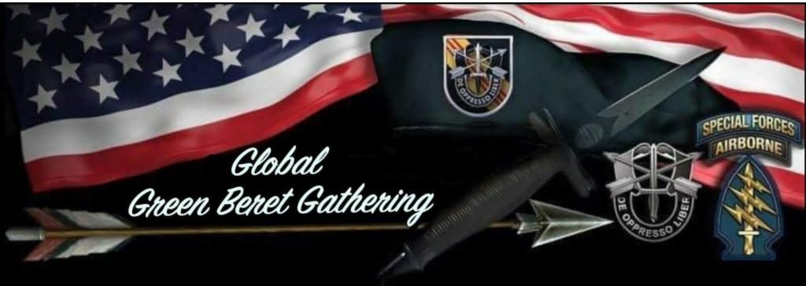
SFA Members (Active and Expired),
During the SFACON 2023 President's meeting a few days ago, SFA approved our SFACON 2024 to take place at the Global Gathering of Green Berets next October 2024. The rooms are going fast. We have already pre-registered 233 cabins + 13 'gifted' cabins for a total of 246. We are already sold out of everything above an ocean view so no more balconies, junior suite, or grand suites. Contact is below for standby requests for higher category cabin.
This will be an epic Global Green Beret Gathering the third week in October of 2024 on a Cruise Ship out of Tampa Florida for 5 days. This is a once in a lifetime event that has never been done before. Don't miss this incredible opportunity. It is far enough out to block out your calendar and make this trip with your family and friends. Your first payment isn't due until July 2023 and you can make up to 4 x payments over time.
Register today for a Green Beret experience like no other. 2,000+ Special Forces Alumni, Gold Star Families, Medal of Honor Recipients, Family, and friends on a 5-day cruise from Tampa, FL. The SF Regimental flag will be flying from the ship’s mast as we sail through the Bahamas. Sail-away party (w/current top music artist), venues for ODA/Company/Group reunions, opportunities for BN/SFG (A) formal dining, gatherings/reunion of different shared experiences (MFF, Combat Diver, SOTIC, SFARTAETC, Vietnam, OEF, OIF, etc...). We will have symposiums where you can hear from The

Originals, Medal of Honor Recipients, Commanders of various organizations like USSOCOM, USASOC, etc. We will be supporting SF small businesses with vendor tables and events planned at the Ports of Call. No worries about drinking and driving, all your needs are in one place. You’ll have the opportunity to come to Tampa early for the golf tournament or stay late to do some amazing things there to include visiting the Cuban district of Ybor City, the aquarium, professional sports, and come nightfall, 7th Avenue in Ybor City heats up, Latin-style. We will even have a motorcycle ride planned for those who love to feel the wind in the face and ride on two-wheels either before or after the cruise. Come celebrate life with your brothers.
All registrations prior to June 24, 2023 will be in a drawing for prizes including a 2-cabin category upgrade (or $1,000.00), 1-cabin category upgrade (or $500.00), and other prizes TBD. Please register early, we need to see our numbers of where we are at in the next 30 days. If we don't meet our goal we will have to open this up to other ARSOF organizations to fill up the ship. There has never been an opportunity like this before, so don't be the one who sees the pictures, videos, smiles and memories after this is all over, wishing you had attended - make the commitment today and sign up.
Click here to register: https://sfali.org/cruise-pre-registration-page/
The rooms are designed to have two occupants. If you don't have someone to come with you, we have
started a forum where folks can go and find someone to defray the cost of the
room. http://pub24.bravenet.com/forum/static/show.php?usernum=1987450266&frmid=10393&msgid=0
What is included: Cabin in selected category for 2 passengers, taxes, port fees, and gratuities. 3 sit down meals a day, snacks and more throughout; non-bottled water, lemonade, iced tea, hot chocolate, and some coffees and teas. There are Vegas type production shows, water slides, comedy club, and all kinds of activities for kids, etc.
If you would like to help plan activities on the ship or in Tampa before/after the cruise, please join my planning committee. My contact info is below. Hope to see you on-board!
DON'T MISS THE BOAT....
DOL,
Pete Tingstrom
President SFA Chapter VIII Hawaii
(808) 436-2901
Special Forces 2024 Cruise Lead Planner and SFACON 2024 Chair
specialforces2024cruise@gmail.com

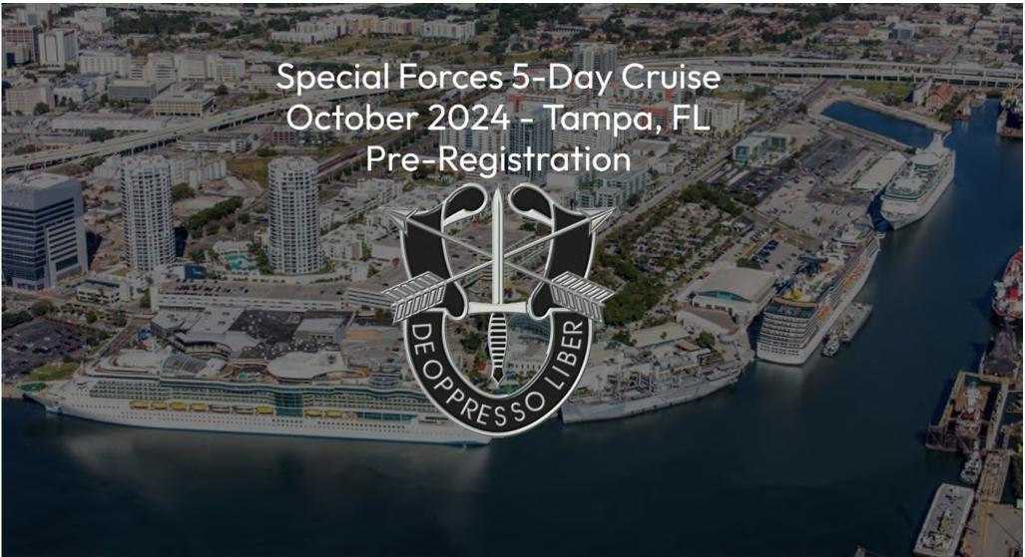
You have received this message from the mailing list of Special Forces Association. If you would prefer not to receive these emails in the future, go to the opt-out page and modify your privacy settings. You can also request to be removed from our database completely.

ReplyForward

