Altman: St. Petersburg hero welcomes new medal honoring OSS, CIA's precursor
Thursday, January 5, 2017 5:30am
- Print

- 0
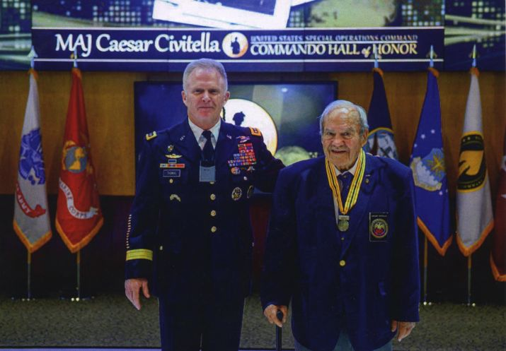
Courtesy of Caesar Civitella
Caesar Civitella, right, lauded the creation by Congress of a special medal honoring members of the former Office of Strategic Services. Civitella is shown here at his induction into the Commando Hall of Honor at MacDill Air Force Base, attended by Army Gen. Raymond “Tony” Thomas III, commander of U.S. Special Operations Command.
More than six decades after the Office of Strategic Services conducted spy missions and commando raids during World War II, Congress has finally acknowledged the organization's work.

RELATED NEWS/ARCHIVE
- 25 receive Carnegie Hero medals
5 Months Ago
- Community chorus in St. Petersburg welcomes all
5 Months Ago
- Medal honors black Marines who served despite discrimination in WWII
1 Month Ago
To Caesar Civitella, 93, a St. Petersburg resident and former OSS member who helped the French resistance and chased Italian despot Benito Mussolini, the December vote to approve the OSS Congressional Gold Medal, and its signing into law by President Barack Obama, was overdue.
"Frankly, it was a long time coming," said Civitella, considered a living legend by commandos and spies.
The award honors the men and women who performed dangerous missions, under the cloak of secrecy, that helped turn the tide of the war, Civitella said. It was the precursor of the modern day Central Intelligence Agency and U.S. Special Operations Command.
Civitella, according to official government records, did his part.
At 11:30 p.m. Aug. 29, 1944, he and the rest of Team Lafayette started their first mission, jumping out of a B-24 Liberator heavy bomber and parachuting behind enemy lines in southern France.
The 14-man OSS operational group was taking part in Operation Dragoon, the allied invasion of southern France. Working with the French Maquis resistance group, Civitella's team captured nearly 3,800 enemy soldiers and 30 Nazi officers, according to Civitella's official government biography.
At its peak, the OSS had about 13,000 members, according to U.S. Sen. Mark Warner, D-Virginia, who co-sponsored the Senate bill. Fewer than 100 are still alive, he said.
Civitella said most of those he served with have died.
"I know guys who would have liked to have seen this medal," he said.
Henry Sonagere, 96, of Stuart, said he, too, is glad to see that Congress authorized the medal, spurred by the OSS Society, a Washington non-profit dedicated to preserving the history of the CIA precursor.
Like Civitella, Sonagere said the award was "long overdue.
"We did a lot to shorten the war," said Sonagere, who served with Civitella helping the French.
The U.S. Mint will make one gold medal for the Smithsonian's National Museum of American History, which will help sell replicas, said OSS Society President Charles Pinck. The OSS Society, he added, will present one of the replicas to U.S. Special Operations Command, headquartered at MacDill Air Force Base. There will also be a presentation ceremony at the Capitol later this year, Pinck said.
Pinck quoted Gen. 'Wild' Bill Donovan, the military officer who started the legendary organization, in saying that OSS personnel performed "some of the bravest acts of the war."
Civitella's work with the OSS was just part of a fabled career.
After leaving the OSS, he enlisted in the Army, where he helped develop Special Forces doctrine, Civitella shipped out in 1961 for the first of his three tours of duty as a soldier in Vietnam. On Aug. 31, 1964, Civitella, a major at the time, retired from the Army.
Less than 24 hours later, he joined the CIA, where he helped design a plan to slow Viet Cong traffic along the infamous Ho Chi Minh trail, a supply route for the North Vietnamese Army and Viet Cong guerillas who ran from North Vietnam, through Laos and Cambodia.
The Air Force seeded the clouds to make it rain, he says. Then aircraft dropped his secret, slippery ingredient.
"We used Calgon dish soap," he told the Times in June.
•••
The Pentagon announced no new troop deaths last week in its ongoing operations.
There have been 2,347 U.S. troop deaths in support of Operation Enduring Freedom in Afghanistan; 32 U.S. troop deaths and one civilian Department of Defense employee death in support of the follow-up, Operation Freedom's Sentinel in Afghanistan; 27 troop deaths and one civilian death in support of Operation Inherent Resolve, the fight against the Islamic State; and one troop death in support of Operation Odyssey Lightning, the fight against Islamic State in Libya.
Contact Howard Altman at haltman@tampabay.com or (813) 225-3112. Follow @haltman.
Altman: St. Petersburg hero welcomes new medal honoring OSS, CIA's precursor 01/05/17 [Last modified: Friday, January 6, 2017 6:14pm]
Photo reprints | Article reprints

